STUDENT CAR USAGE POLICY

To ensure safety of students, Laidley SHS has the following approach to managing students who drive cars to school or students who get a lift with another student who drives a car to school.

- All drivers must have completed the required permission form and have this signed by their parents prior to driving a vehicle to school.

- All passengers must have completed the required permission form and have this signed by their parents prior to travelling in a vehicle driven by another student.

- Cars are not to be used during school hours (8:30am to 2.55pm) except under the following conditions:
  - Students have a pass to leave school early (arranged through the office).
  - Students have made prior arrangements with the school to drive to a school organised excursion or activity AND only approved passengers travel in the vehicle.

- In all cases paperwork must be signed by the Principal.

- Students who drive cars to school are reminded that:
- You must park on Edward Street at the back of the school or in parallel parks on Alfred St (no student is to park in the diagonal parks on Alfred St or the staff car park).
- You are driving a car in a school zone, which has a speed limit of 40km/h.
- Cars are out of bounds at all times except when you arrive and leave. There is no need to sit in your car for any length of time after you arrive.
- Noise should be kept at a minimum i.e. turn your radios down before you arrive at school.

Yours faithfully
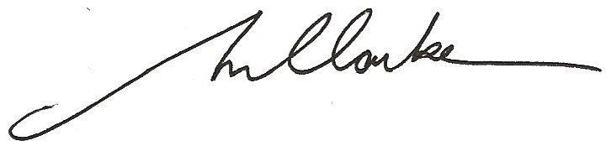

Michael Clarkson Principal
Laidley State High School

